**Navigating a File System - Classwork**

|  |  |  |
| --- | --- | --- |
|  | Questions | Your responses |
| 1. How many root directories are on the Windows machine to the left? |  |
| 2. List its root directories. |  |
| 3. How many folders does the C drive have? |  |
| 4. How many of them do NOT have a subfolder? |  |

For the next set of questions:

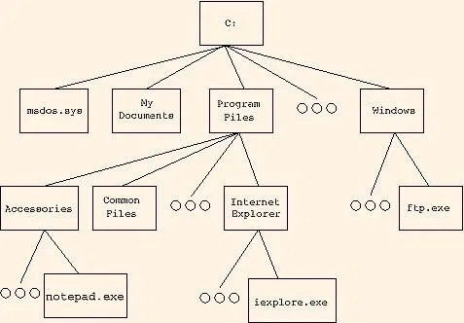

|  |  |
| --- | --- |
| 6. Name this file system’s root directory. |  |
| 7. Write the full path of the ftp program. |  |
| 8. If you’re working in the Windows folder, write the relative path of the ftp program |  |
| 9. At least how many files does the Windows directory have? |  |

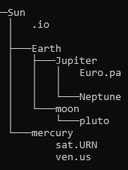

You can use any program to do this.

Make a new folder/directory on your computer, and in it make new files and folders to recreate the structure you see on the left. Keep it simple using programs like Windows’ NotePad or OSX’s TextEdit. The files can be empty.

To name files with extensions different from the usual, you may have to be careful when saving. Change the type to “All Files” so no extra extensions like txt, docx, etc. would be appended to the name. See screenshot below.

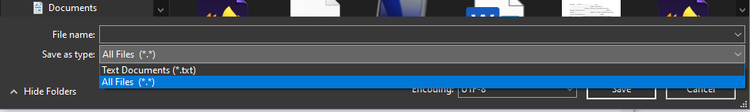

11. Paste screenshot(s) to prove you did *everything* correctly (if you know command line, you can navigate to the parent directory and then type **tree**).

|  |
| --- |
|  |